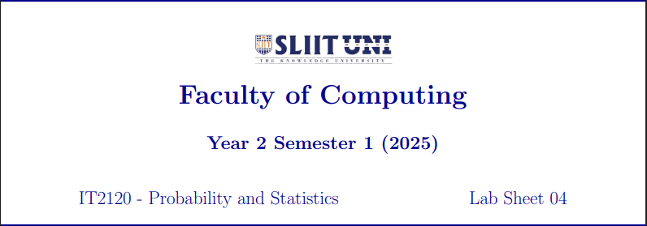

IT23154308

GAMLAKSHA G.D.A.S

3.This is a Right-skewed distribution.

